Technical Architecture:

Project Design Phase-II Technology Stack (Architecture & Stack)

|  |  |
| --- | --- |
| Date | 09-11-2022 |
| Team ID | PNT2022TMID27543 |
| Project Name | Emerging Methods for Early Detection of  Forest Fires |

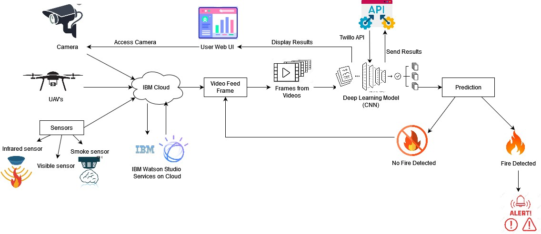

Table-1 : Components & Technologies:

|  |  |  |  |
| --- | --- | --- | --- |
| **S.No** | **Component** | **Description** | **Technology** |
| 1. | User Interface | The user uses the console to access the interface | Python/HTML, CSS, JavaScript and  react.Js |
| 2. | Input | Video Feed | Web Camera/Video on a site |
| 3. | Conversion | Video inputted is converted into Frames | Frame Converter |
| 4. | Feeding the Model | The Frames are sent to the Deep learning model | Our Model |
| 5. | Dataset | Using Test set and train set , train the model | Data set from Cloud Storage , Database |
| 6. | Cloud Database | Database Service on Cloud | IBM DB2, IBM Cloudant |
| 7. | File Storage | File storage requirements | IBM Block Storage or Other Storage  Service or Local Filesystem |
| 8. | External API-1 | Purpose of External API used in the application | IBM Weather API |
| 9. | External API-2 | Purpose of External API used in the application | User authentication |
| 10. | Deep Learning Model(CNN) | Gets the image, processes it, and detects the presence of  fire | Faster RCNN, R-FCN, SDD, YOLO V3 |
| 11. | Infrastructure (Server / Cloud) | Application Deployment on Local System / Cloud Local Server Configuration:  Cloud Server Configuration : | Java/python, React.Js, JavaScript, HTML, CSS, IBM Cloud, OPEN CV, Anaconda  Navigator, Local. |

Table-2: Application Characteristics:

|  |  |  |  |
| --- | --- | --- | --- |
| **S.No** | **Characteristics** | **Description** | **Technology** |
| 1. | Open-Source Frameworks | Python Flask framework is used | Technology of Opensource framework |
| 2. | Security Implementations | Mandatory Access Control (MAC) and Preventative  Security Control is used | e.g. SHA-256, Encryptions, IAM Controls,  OWASP etc. |
| 3. | Scalable Architecture | High scalability with 3-tier architecture | Web server – HTML ,CSS ,JavaScript Application server – Python , Anaconda  Database server –IBM DB2 |
| 4. | Availability | Use of load balancing to distribute traffic across  servers | IBM load balancer |
| 5. | Performance | Enhance the performance by using IBM CDN | IBM Content Delivery Network |